Working with data in your maps

In this chapter, you’ll learn:
- How to join data to an empty map using the join function
- How to change field values using string functions

Data used:
- tl_2023_us_county.shp
- medinc_county.csv
- COUNTRIES.shp
- globind.csv

Now that you’re familiar with bringing a map into QGIS and altering its appearance, we’ll go one step further and learn how to analyze data. We’re going to do something that you should be familiar with from database managers – joining tables.

Most maps that you acquire do not contain the data like the one in the last chapter did. Usually, you have to connect your data to your map.

I downloaded the latest counties file from the U.S. Census Bureau’s TIGER line file collection: https://www.census.gov/geographies/mapping-files/time-series/geo/tiger-line-file.html

You’ll get a ZIP file containing all the components for the counties shape file, which is called tl_2023_us_county.shp
Let’s set up a clean map by clicking on the top left icon  or by going to Project | New on the main menu. We do this because QGIS isn’t good at cleaning up for itself.

Right now our map contains only geographic information. If we want to add some data from the Census or any other source where county geography is included. I went to censusreporter.org and downloaded median household income by county. I called the file medinc_county.csv.

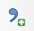
Add csv by clicking the Add Delimited Text icon. (Otherwise QGIS may make bad decisions about your formats.)

When you add it, browse to find your medinc_county.csv and set column formats.

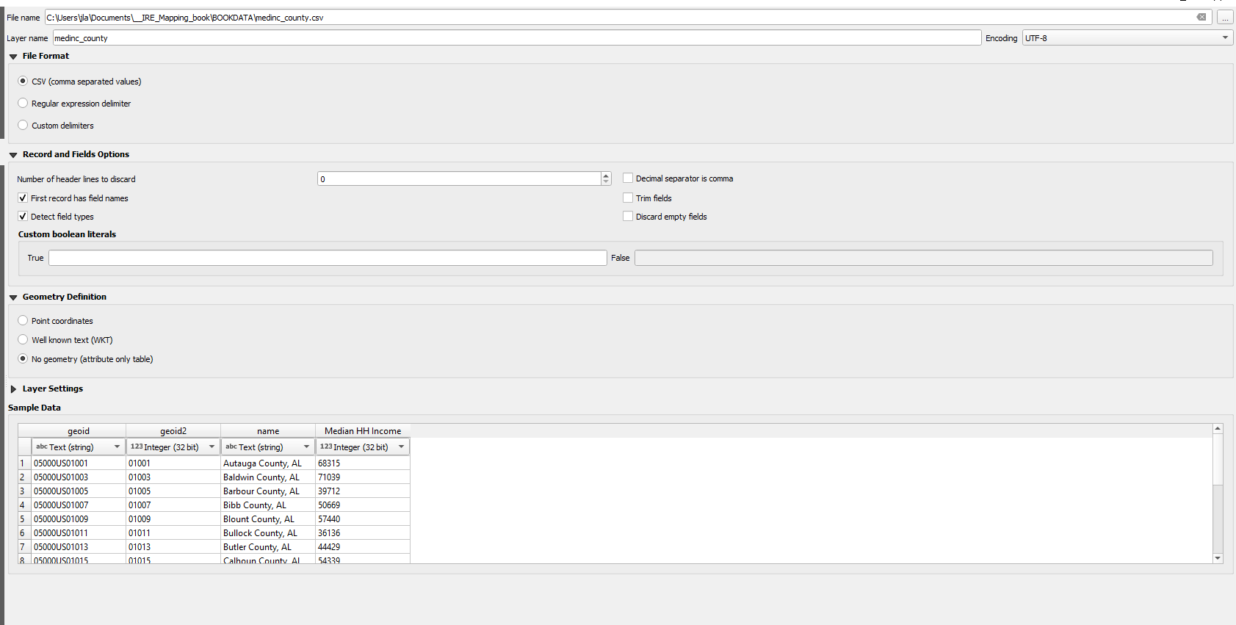

When we add the file directly, without going through this menu, QGIS makes things that we want to be numbers text and text numbers. Make sure that GEOID2 is text (string) format and that Median HH Income is a number.

Take a look at the table you just imported: geoid2 should still have leading zeros and medhhinc should be right justified, which indicates numeric format. To join, you must have a field in your csv that matches a field in your shapefile. It doesn’t have to have the same name, but it must be the same length and format.

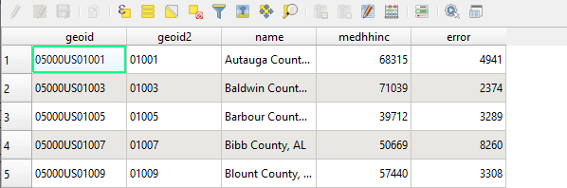

We need the data to match the geographic identifier in our map, which is called geoid. The format of geoid in the map matches the format of geoid2 in our imported table.

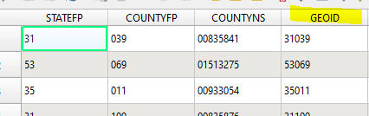

Now we’re ready to join!
Go to the properties for the counties layer file and click on JOINS in the left menu. 
Then click the plus sign on the button to add the join.

It’s important to remember that to join data to a map, you need to start with the layer rather than the data file. I like to think of it as standing in the Jello mold so I can bring in the Jello (data).
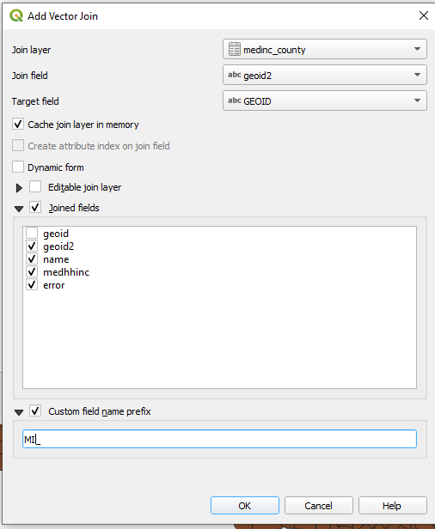
The first drop-down menu will ask for the data you want to join to the layer. In this case, we have only one table. As you build larger maps with more data, you may have multiple options.

Next, the form will ask what fields to join on. In this case, we have a five-character state/county fips code. It’s called geoid2 in the medhhinc data and geoid in the layer.

Finally, choose the fields you want to include and add a prefix that is short to custom prefix. The custom prefix is what QGIS sticks onto the front of the new columns. If it’s too long, you won’t see the column names.

Click OK. QGIS will pour your data into your map. To double check, right click on the layer and look at the attribute table. Scroll all the way to the right to make sure your data was connected correctly.
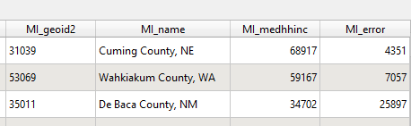
Note: The data is not permanently attached to your map, it’s a temporary join in this project. To permanently attach it, you would need to create a new layer with the data using Export.

Woo-hoo! You did your first join. Now, make a choropleth map based on median income.
Remember to save your project just like you did earlier. You may call it anything you like.

ON YOUR OWN
Practice joining, using country-by-country indicator data. Use the shapefile COUNTRIES.shp and the data globalind.csv. Remember to bring your csv in using the add csv button. There are a few fields you could use to join. See if you can figure out by looking at the attribute table for both files.

Here’s are the definitions of the fields:
- Gni: Gross national income per capita
- Skulspend: education expenditures per capita
- Death: death rate
- Healthexp: health expenditures per capital
- Unemp: Unemployment rate
- Water: % with access to clean water
- Skul: % in school
- Maternal: % risk of maternal death

Try to do some mapping on your own.

In the next chapter, we’ll begin combining maps.

